**Contributor name:** Nitesh Sharma

**Book Proposed:** Principles And Modern Applications Of Mass Transfer Operations By J. Benitez

**Total Chapters:** 09

**Total Examples:** 118

**Codable Examples:** 93

**Chapter 1: Fundamentals of Mass transfer**

Example 1.1 – Codable

Example 1.2 – Codable

Example 1.3 – Codable

Example 1.4– Non-Codable (Reason: Theoretical example with the purpose of proving a concept)

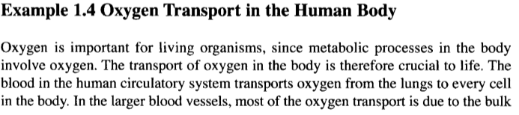

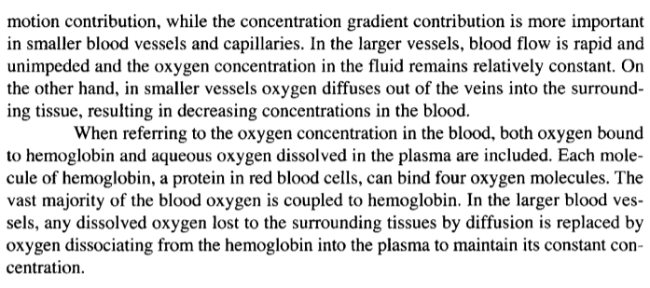

Example 1.5 – Non-Codable (Reason: Theoretical example with the purpose of proving a concept)

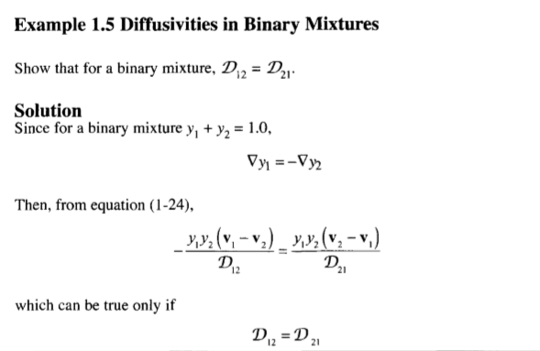

Example 1.6 – Codable

Example 1.7 – Codable

Example 1.8 – Codable

Example 1.9 – Codable

Example 1.10 – Codable

Example 1.11 – Codable

Example 1.12 – Codable

Example 1.13 – Codable

Example 1.14 – Codable

Example 1.15 – Codable

Example 1.16 – Codable

Example 1.17– Non-Codable (Reason: There is no Scope for computation )

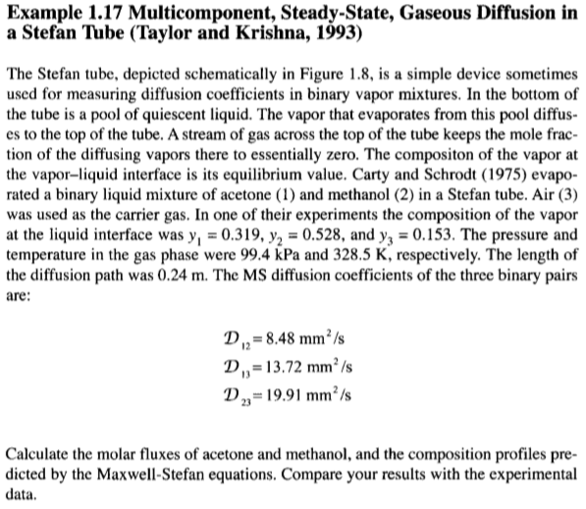

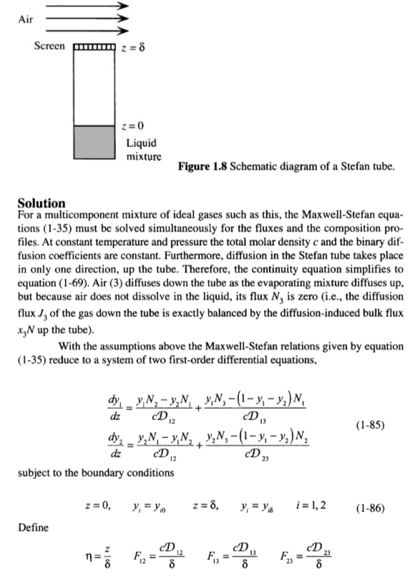

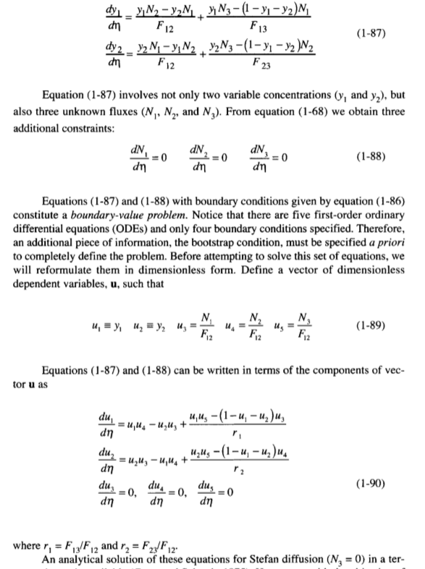

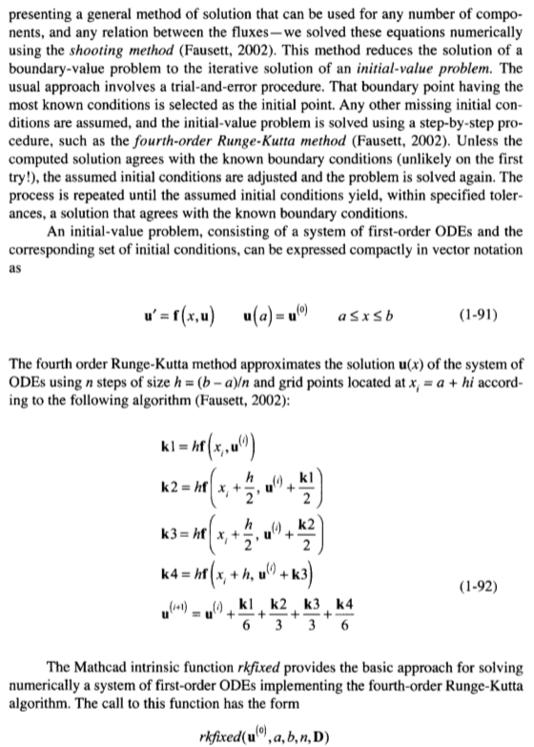

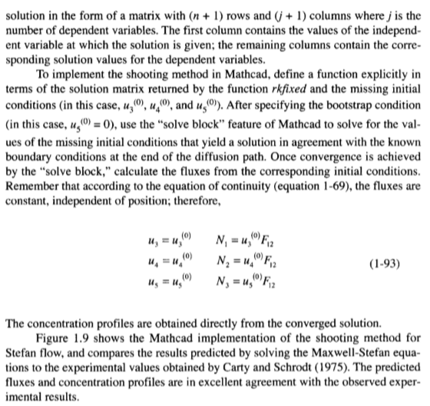

Example 1.18– Non-Codable (Reason: There is no scope for Computation)

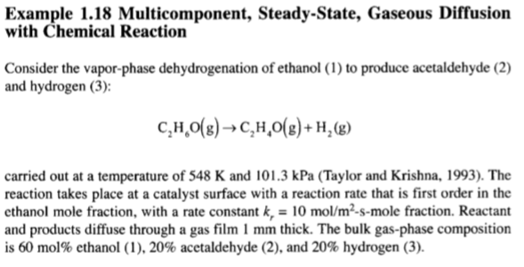

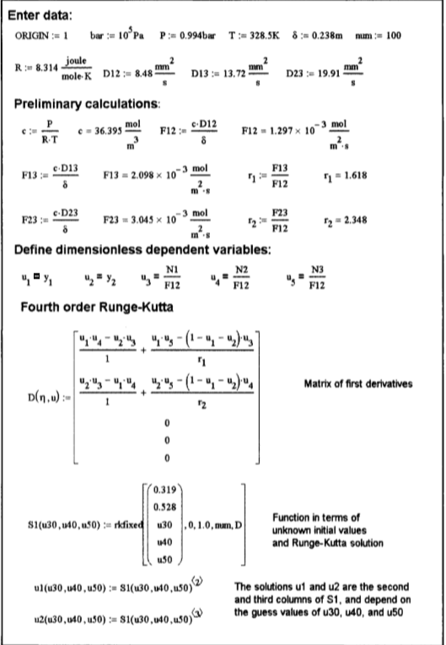

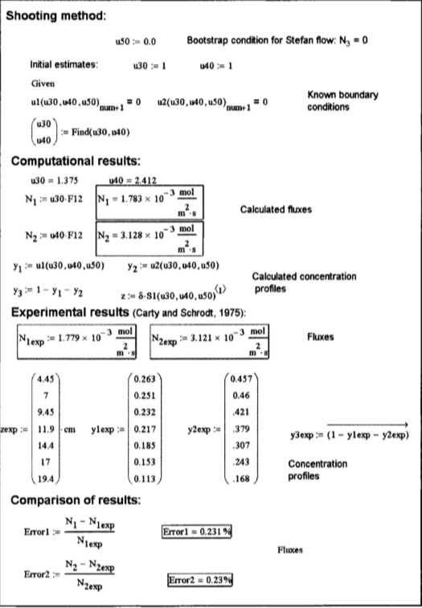

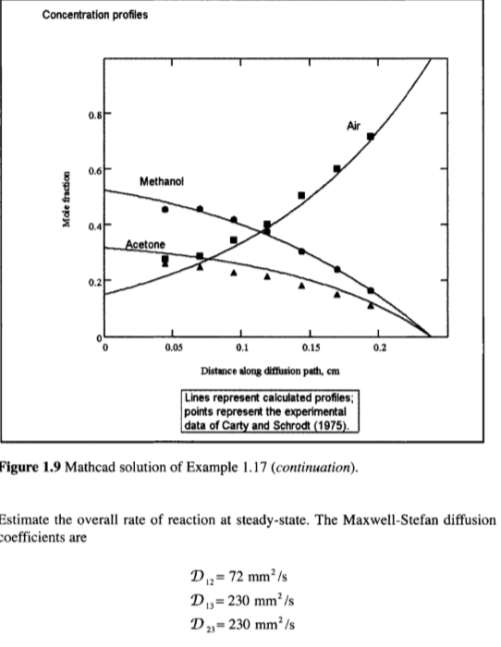

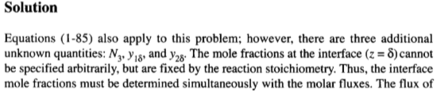

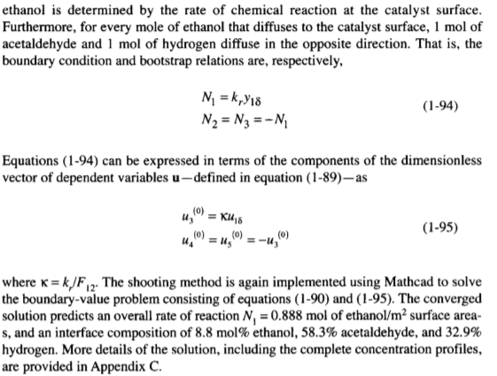

Example 1.19 – Codable

Example 1.20 – Codable

Example 1.21 – Codable

Example 1.22 – Codable

Example 1.23 – Codable

Example 1.24 – Codable

Example 1.25– Non-Codable (Reason: Theoretical example with the purpose of proving a concept)

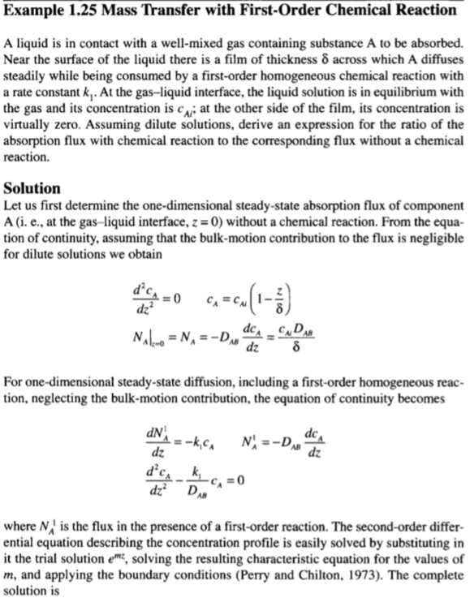

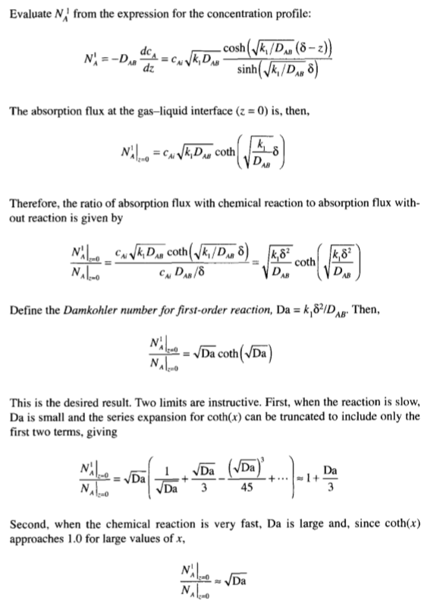

Example 1.26– Non-Codable (Reason: Theoretical example with the purpose of proving a concept)

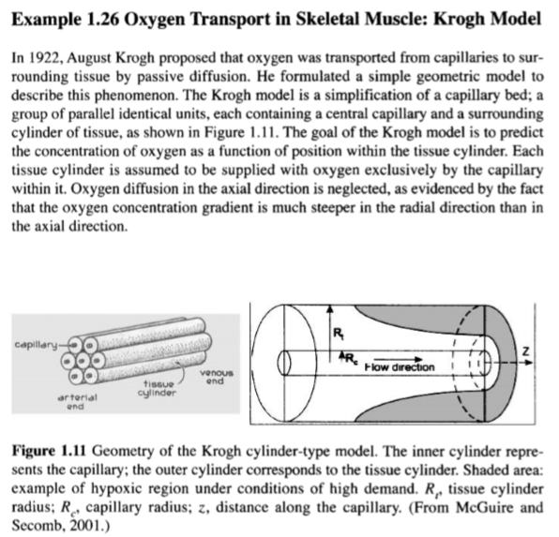

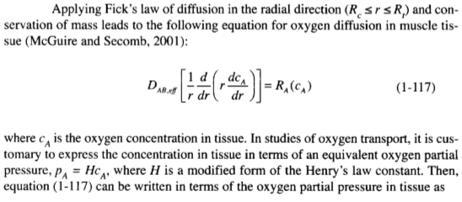

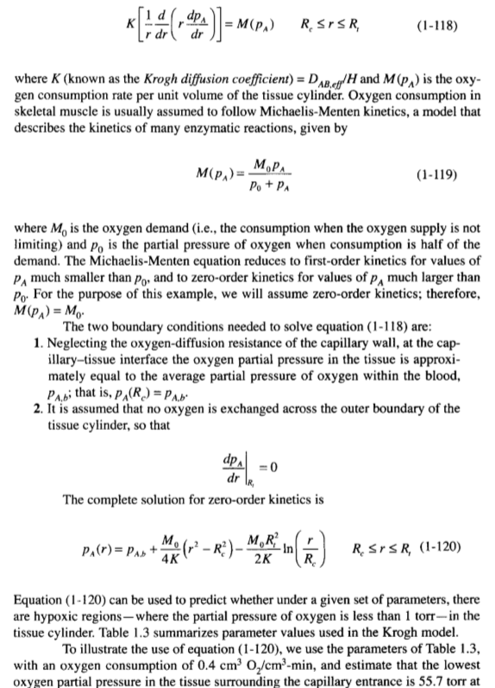

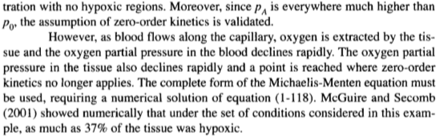

**Chapter 2: Convective Mass Transfer**

Example 2.1 – Codable

Example 2.2 – Codable

Example 2.3 – Codable

Example 2.4 – Codable

Example 2.5 – Non-Codable (Reason: There is no scope of Computation)

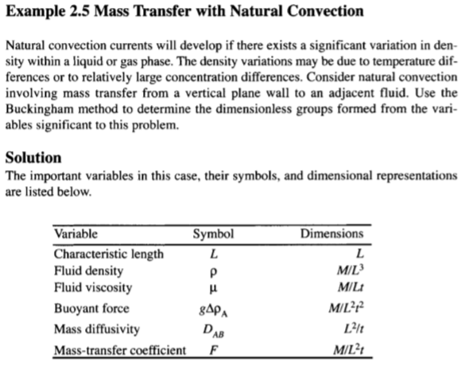

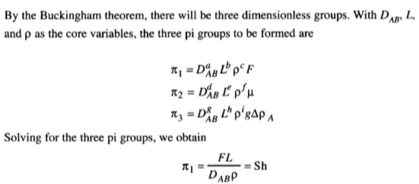

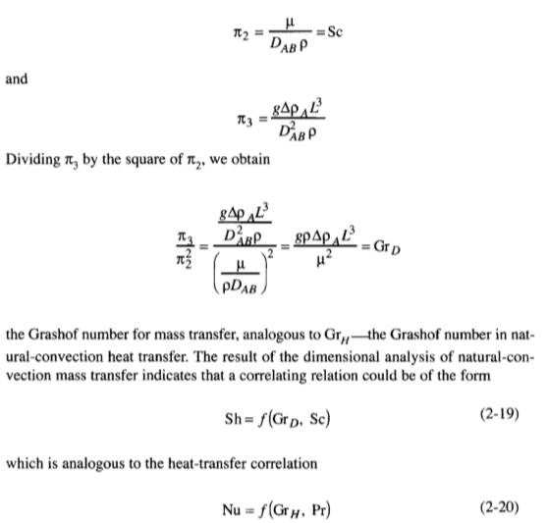

Example 2.6 – Codable

Example 2.7 – Codable

Example 2.8 – Codable

Example 2.9 – Codable

Example 2.10 – Codable

Example 2.11 – Codable

Example 2.12 – Codable

Example 2.13 – Codable

Example 2.14 – Codable

Example 2.15 – Codable

**Chapter 3: Interphase Mass Transfer**

Example 3.1 – Codable

Example 3.2 – Codable

Example 3.3 – Codable

Example 3.4 – Codable

Example 3.5 – Codable

Example 3.6 – Codable

Example 3.7 – Codable

Example 3.8 – Codable

Example 3.9 – Codable

Example 3.10 – Codable

**Chapter 4: Equipment for Gas Liquid Mass Transfer Operations**

Example 4.1 – Non-Codable (Reason: There is no scope of computation)

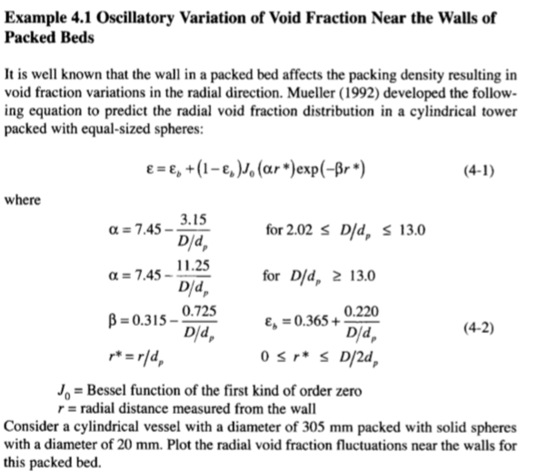

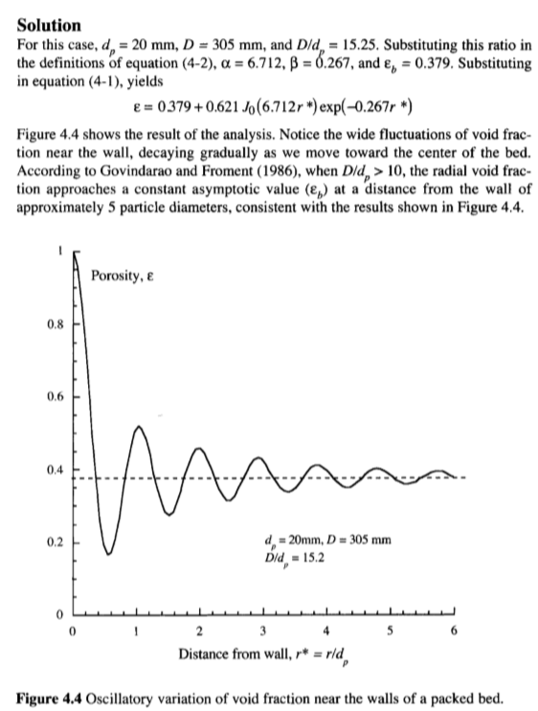

Example 4.2 – Codable

Example 4.3 – Codable

Example 4.4 – Codable

Example 4.5 – Codable

Example 4.6 – Codable

Example 4.7 – Codable

Example 4.8 – Codable

Example 4.9 – Codable

Example 4.10 – Non-Codable (Reason: Its Theoretical and no scope of computation )

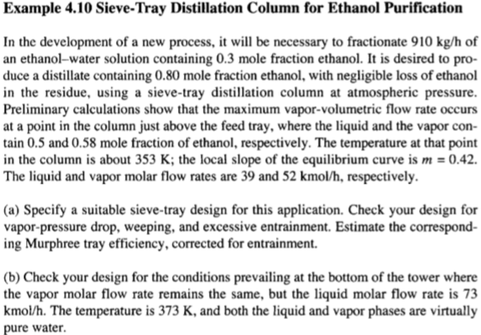

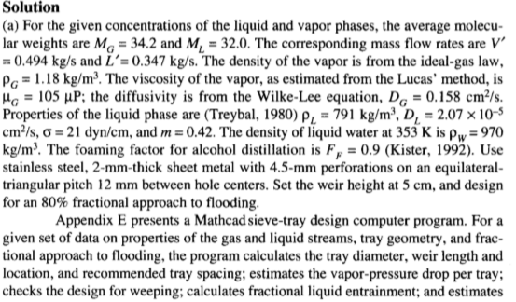

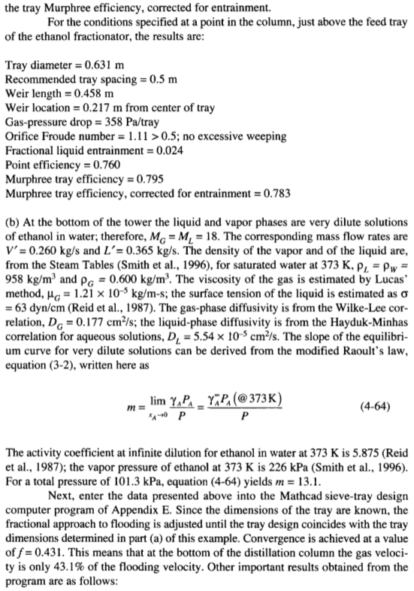

**Chapter 5: Absorption and Stripping**

Example 5.1 – Codable

Example 5.2 – Non-Codable (Reason: Derivative of variables has been performed resulting in a variable expression as the final solution)

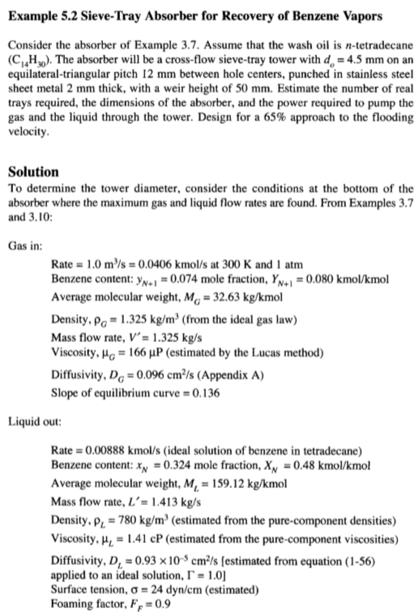

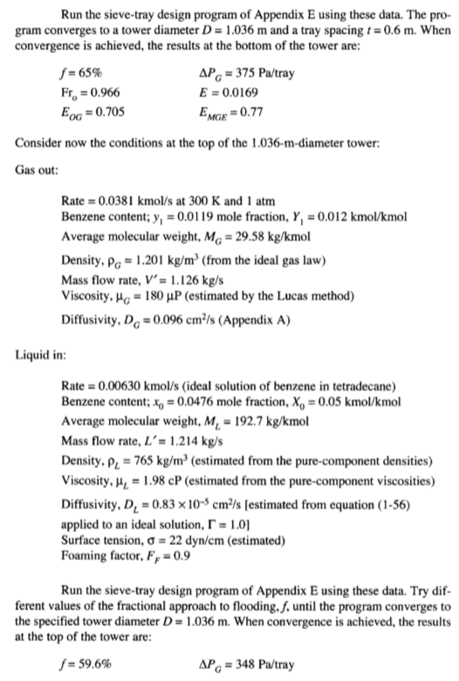

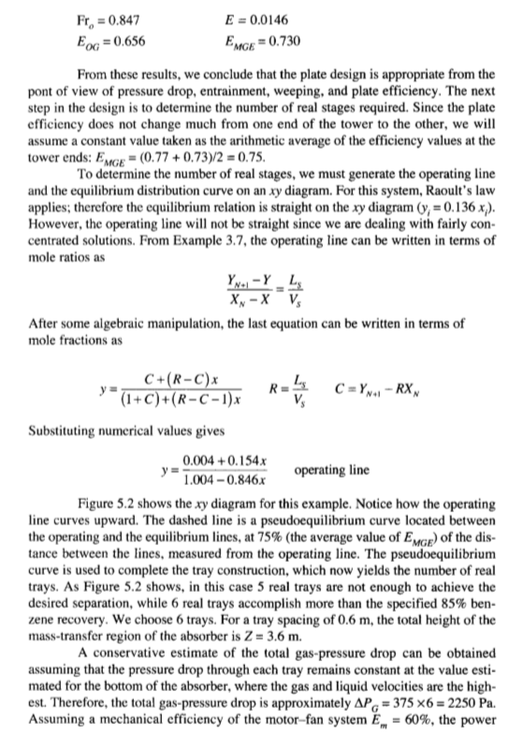

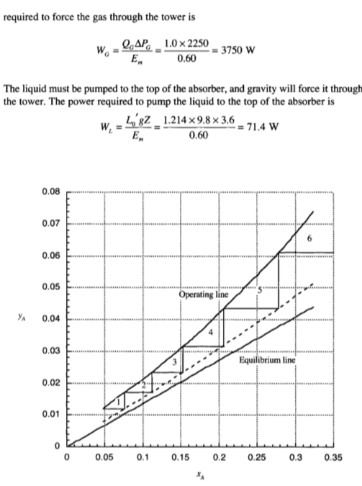

Example 5.3 – Codable

Example 5.4 – Codable

Example 5.5 – Codable

**Chapter 6: Distillation**

Example 6.1 – Codable

Example 6.2 – Codable

Example 6.3 – Codable

Example 6.4 – Codable

Example 6.5 – Non-Codable (Reason: Theoretical example with the purpose of proving a concept)

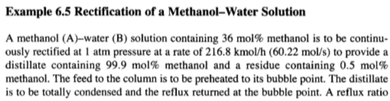

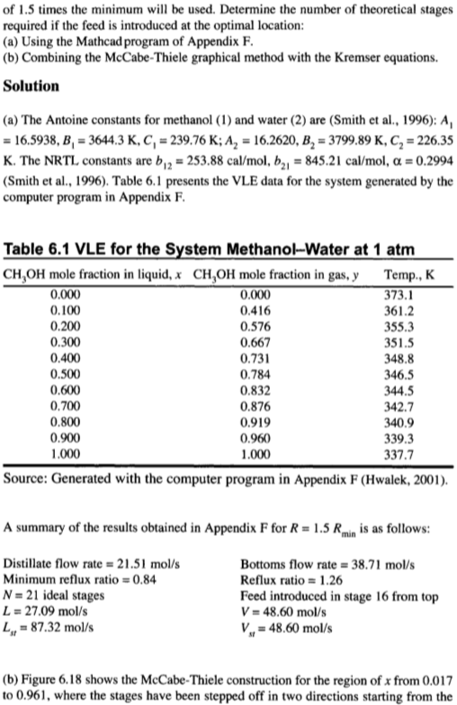

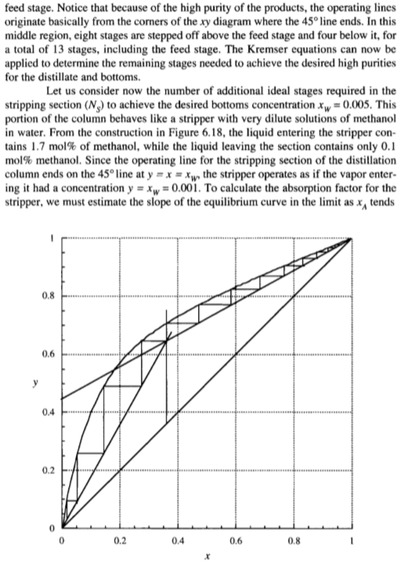

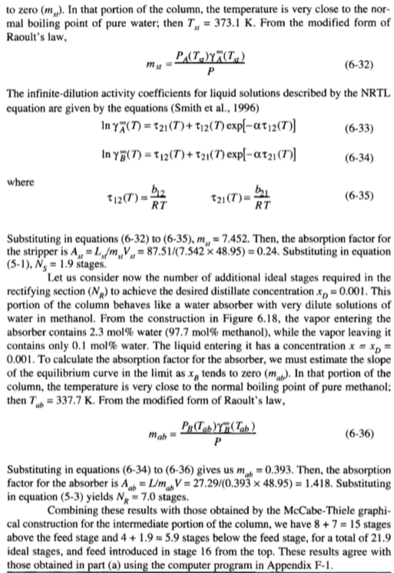

Example 6.6 – Non-Codable (Reason: Theoretical example with the purpose of proving a concept)

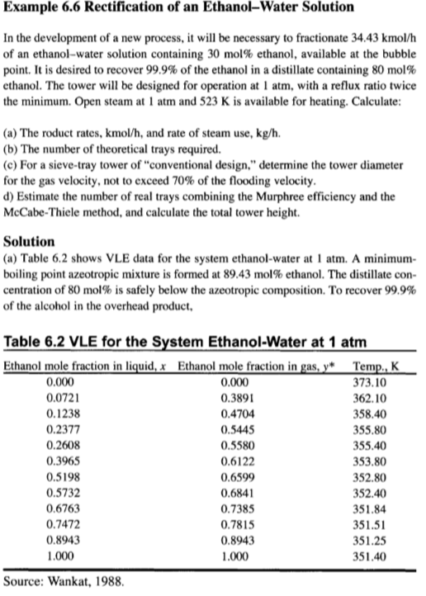

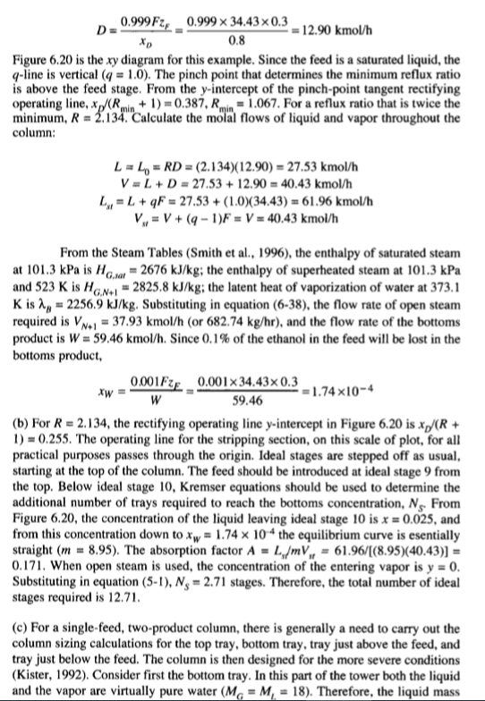

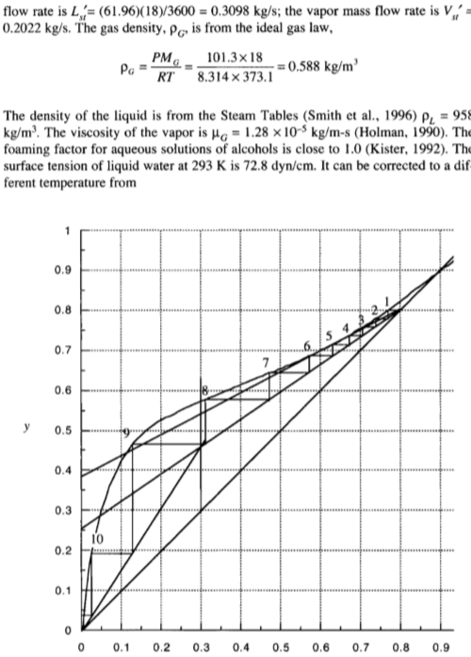

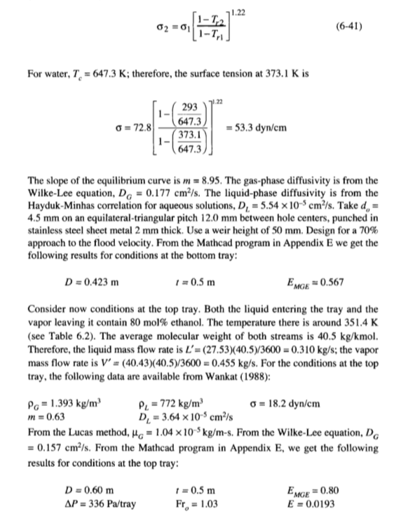

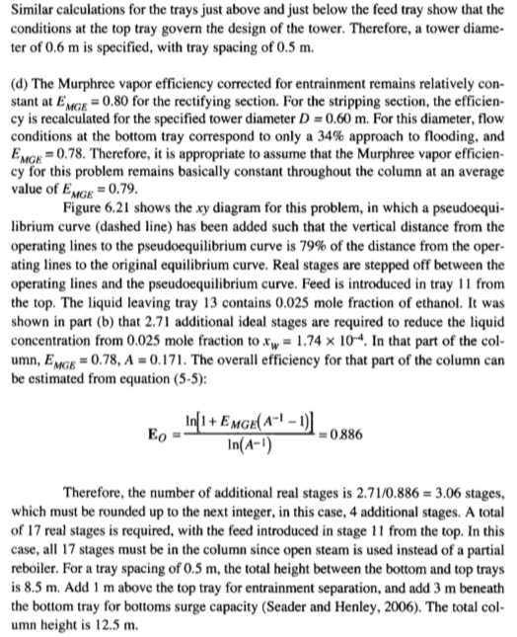

Example 6.7 – Codable

Example 6.8 – Non-Codable (Reason: Integration of variables has been performed resulting in a variable expression as the final solution)

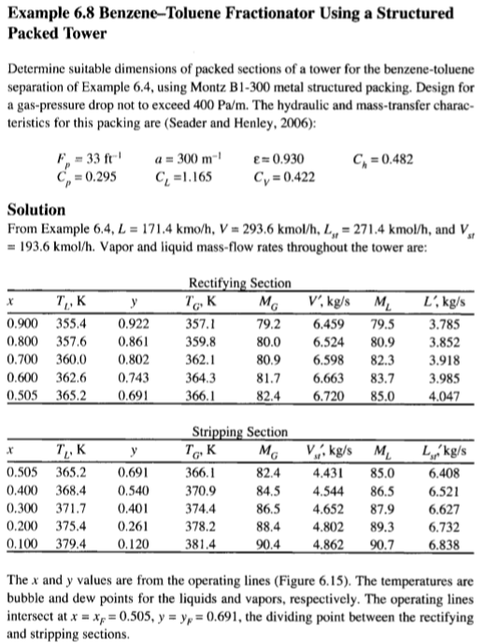

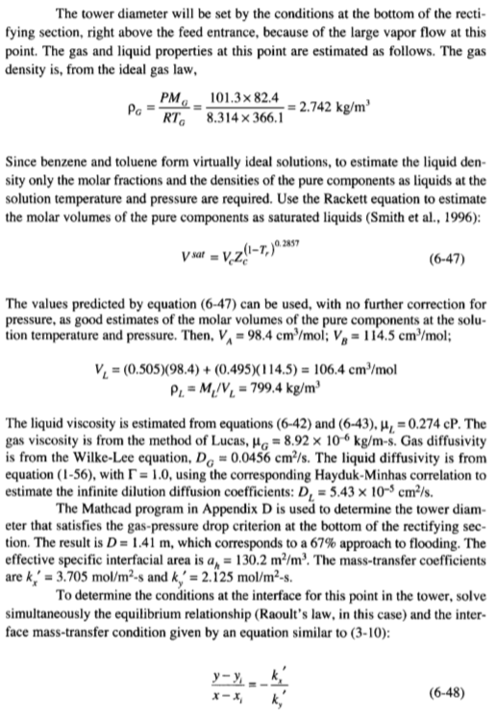

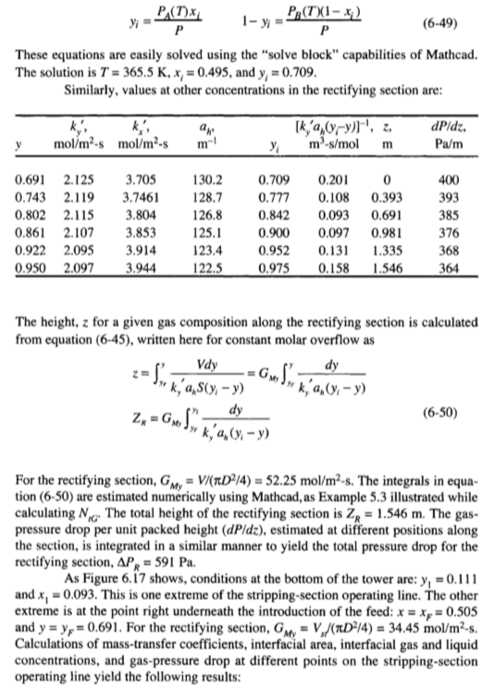

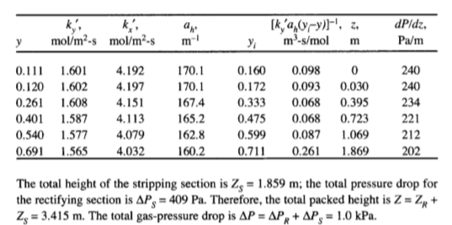

Example 6.9 – Non-Codable (Reason: Theoretical example with the purpose of proving a concept)

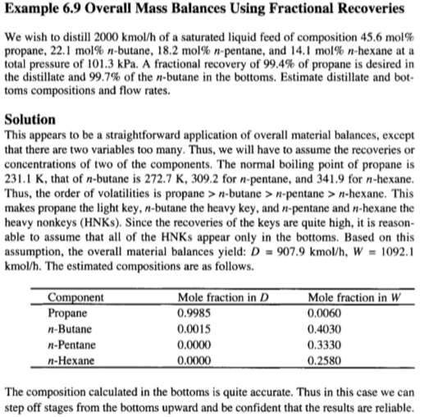

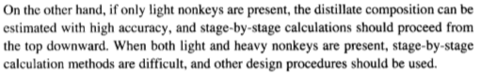

Example 6.10 – Codable

Example 6.11 – Codable

Example 6.12 – Codable

Example 6.13 – Codable

Example 6.14 – Codable

Example 6.15 – Non-Codable (Reason: Theoretical example with the purpose of proving a concept)

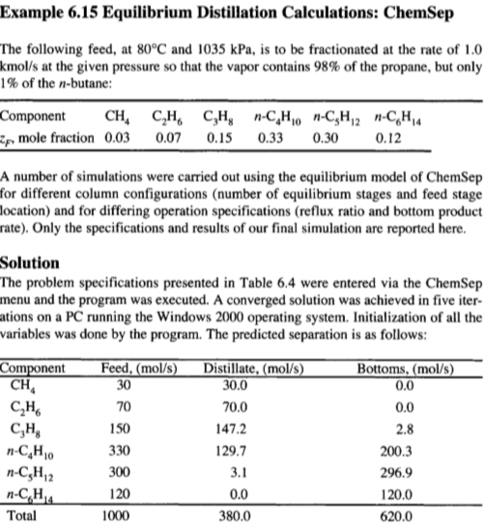

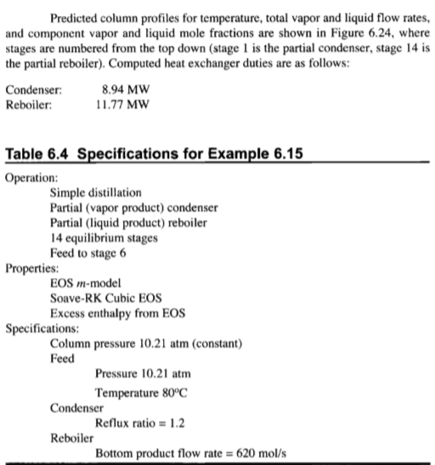

Example 6.16 – Non-Codable (Reason: Theoretical example with the purpose of proving a concept)

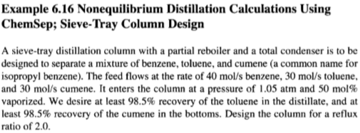

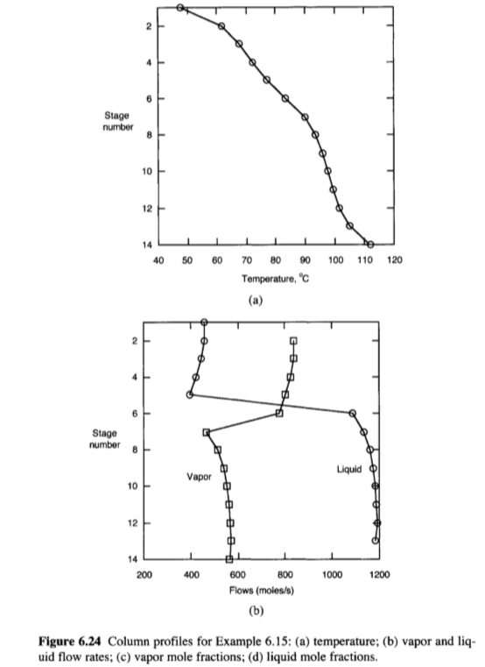

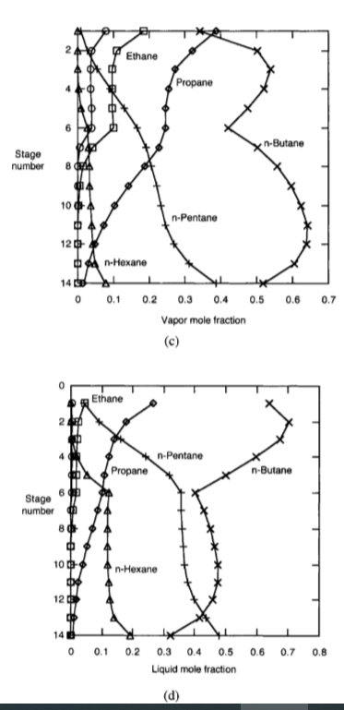

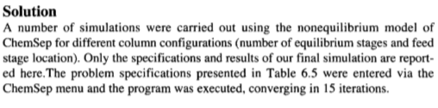

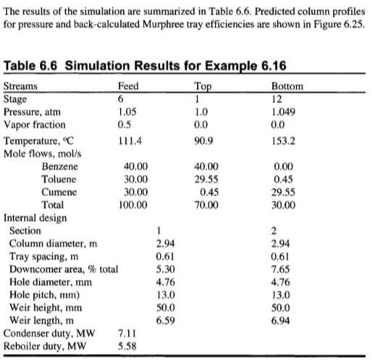

Example 6.17 – Non-Codable (Reason: Theoretical example with the purpose of proving a concept)

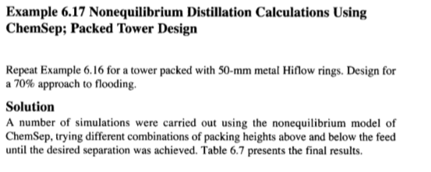

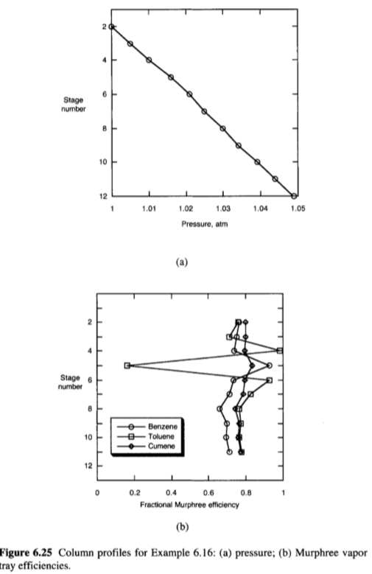

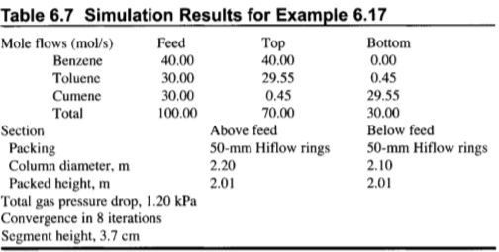

Example 6.18 – Non-Codable (Reason: Integration of variables has been performed resulting in a variable expression as the final solution)

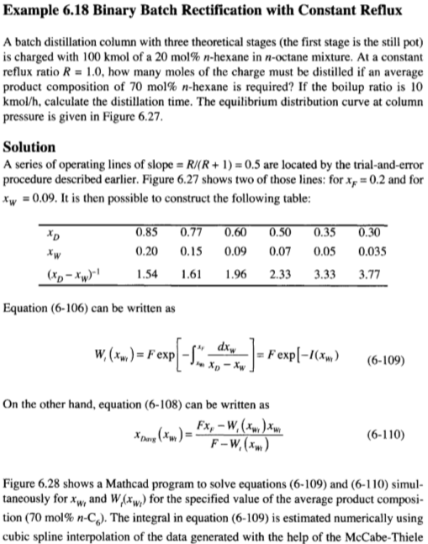

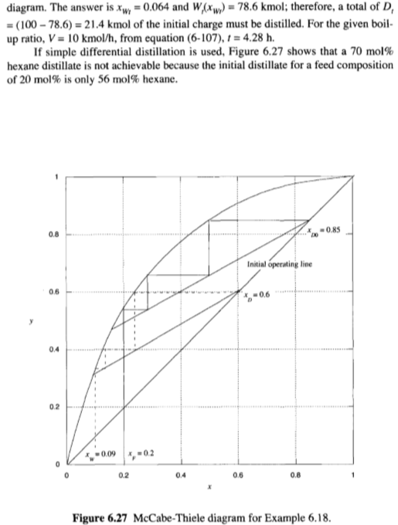

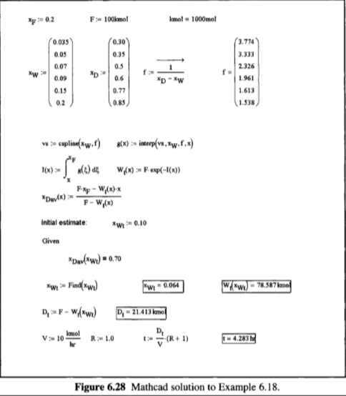

Example 6.19 – Non-Codable (Reason: Theoretical example with the purpose of proving a concept)

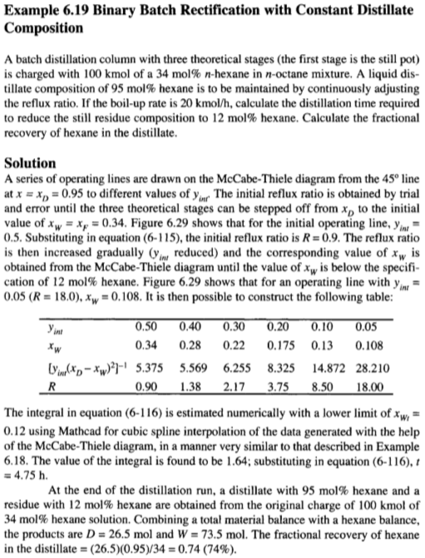

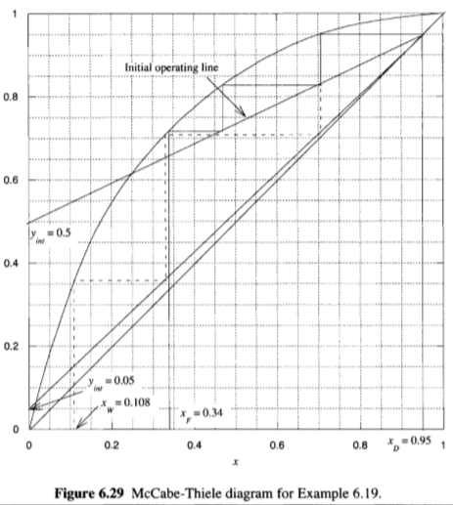

**Chapter 7: Liquid Liquid Extraction**

Example 7.1 – Codable

Example 7.2 – Codable

Example 7.3 – Non-Codable (Reason: Theoretical example with the purpose of proving a concept)

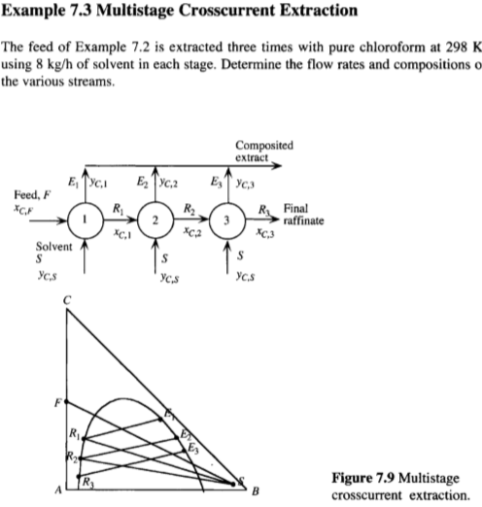

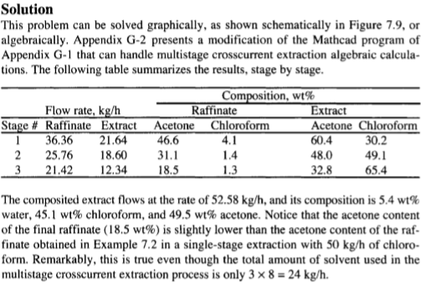

Example 7.4 – Codable

Example 7.5 – Codable

Example 7.6 – Codable

Example 7.7 – Codable

Example 7.8 – Codable

Example 7.9 – Codable

Example 7.10 – Codable

Example 7.11 – Codable

**Chapter 8: Humidification Operations**

Example 8.1 – Codable

Example 8.2 – Codable

Example 8.3 – Codable

Example 8.4 – Codable

Example 8.5 – Codable

Example 8.6 – Codable

Example 8.7 – Codable

Example 8.8 – Codable

**Chapter 9: Membranes and Other Solid Sorption Agents**

Example 9.1 – Codable

Example 9.2 – Codable

Example 9.3 – Non-Codable (Reason: : Integration of variables has been performed resulting in a variable expression as the final solution)

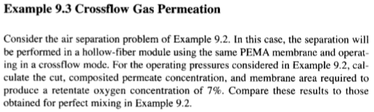

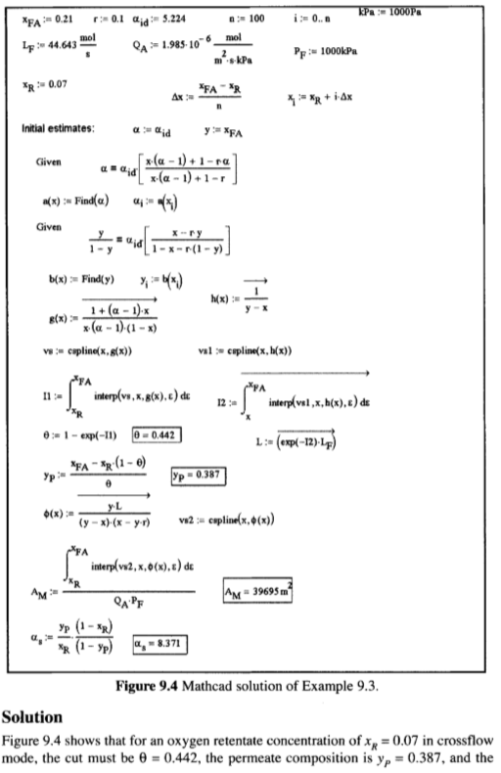

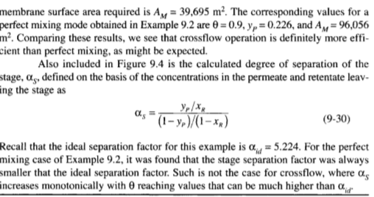

Example 9.4 – Codable

Example 9.5 – Codable

Example 9.6 – Non-Codable (Reason: : Integration of variables has been performed resulting in a variable expression as the final solution)

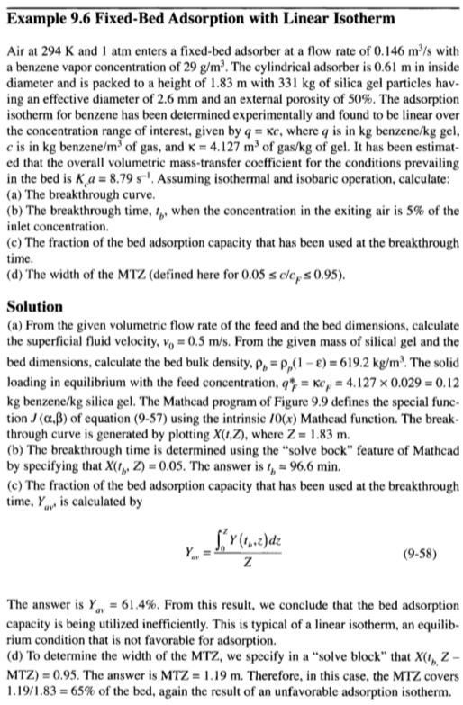

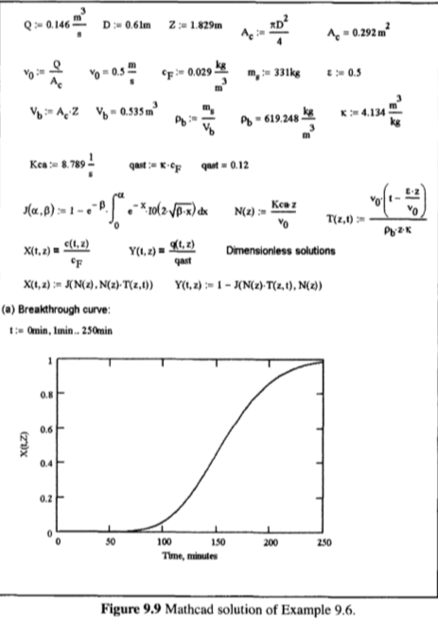

Example 9.7 – Non-Codable (Reason: There is no scope for computation)

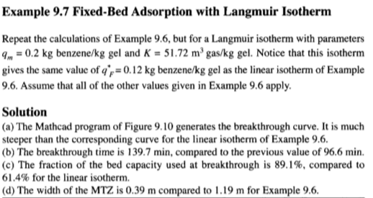

Example 9.8 – Codable

Example 9.9 – Codable

Example 9.10 – Non-Codable (Reason: Theoretical example with the purpose of proving a concept)

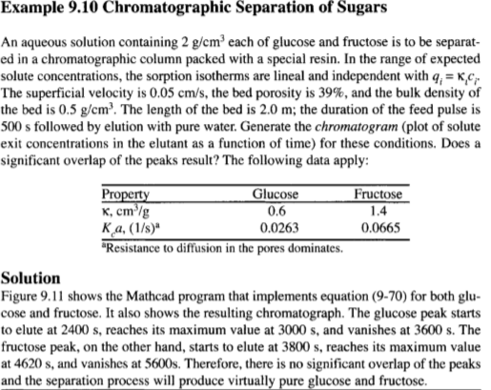

Example 9.11 – Codable

Example 9.12 – Codable

Example 9.13 – Codable

Example 9.14 – Non-Codable (Reason: There is no scope of computation)

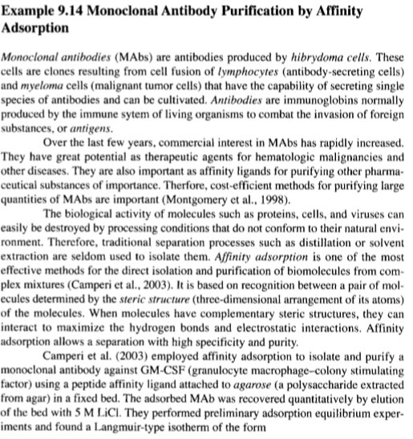

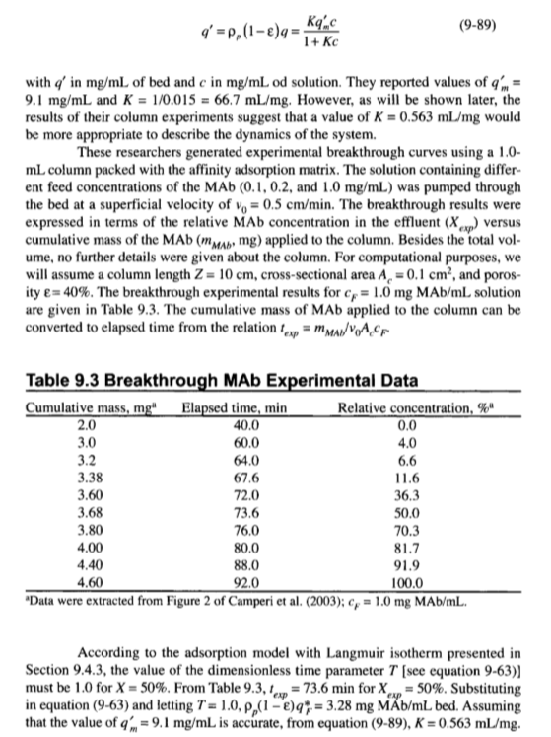

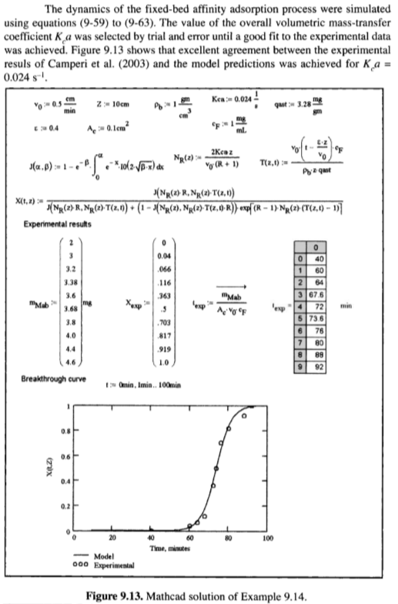

Example 9.15 – Non-Codable (Reason: Theoretical example with the purpose of proving a concept)

